MODULE-01:

01.conversion of time-

#include<stdio.h>

int main()

{

int seconds,minutes,hours;

printf("enter the num of hours",hours);

scanf("%d",&hours);

minutes=60\*hours;

seconds=60\*minutes;

printf("minutes=%d\n",minutes);

printf("seconds=%d",seconds);

return 0;

}

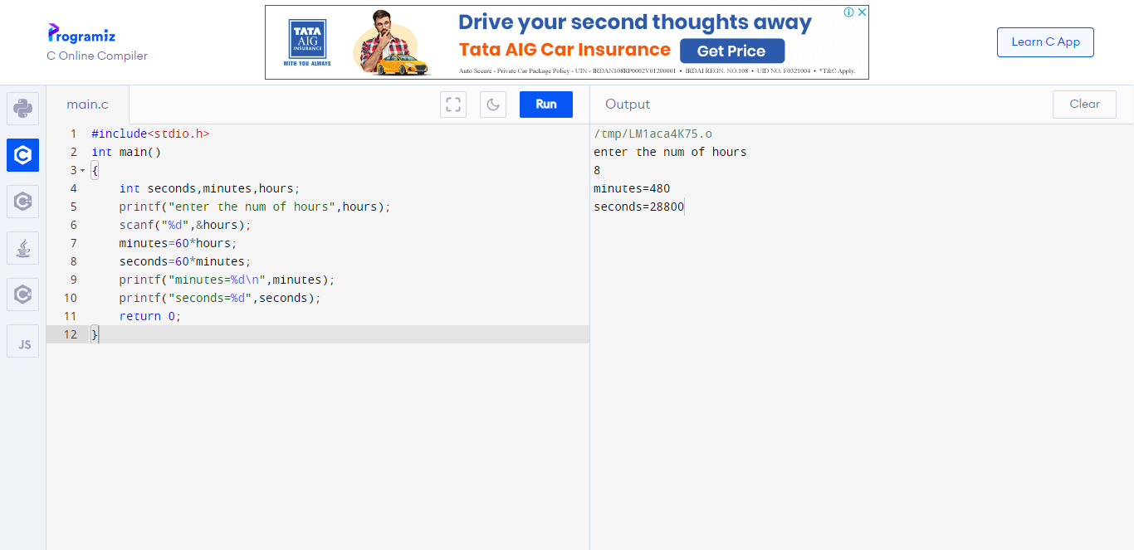

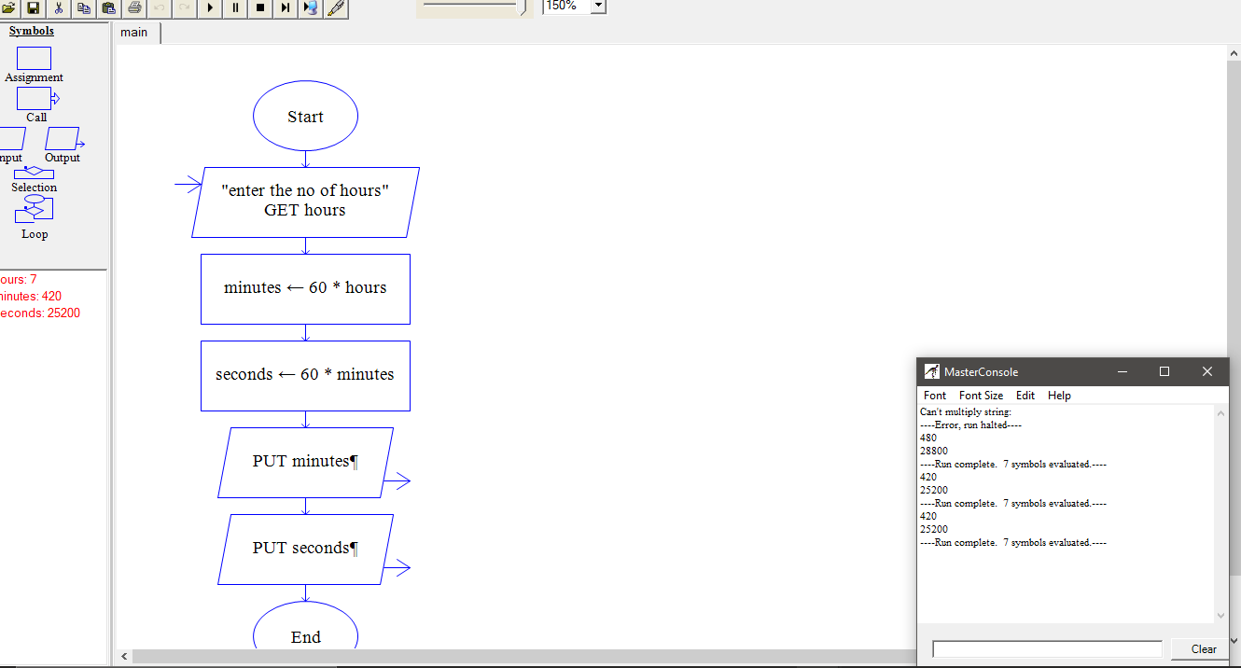

02.conversion of distance-

#include<stdio.h>

int main()

{

int km,m;

printf("enter the distance in km");

scanf("%d",&km);

m=(1/1000)\*km;

printf("the distance in m is %d",m);

return 0;

}

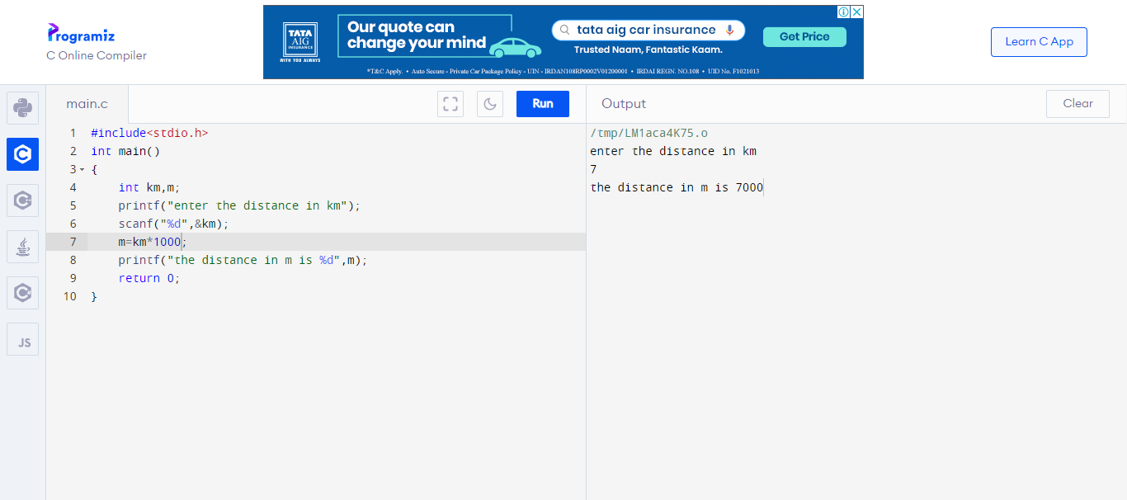

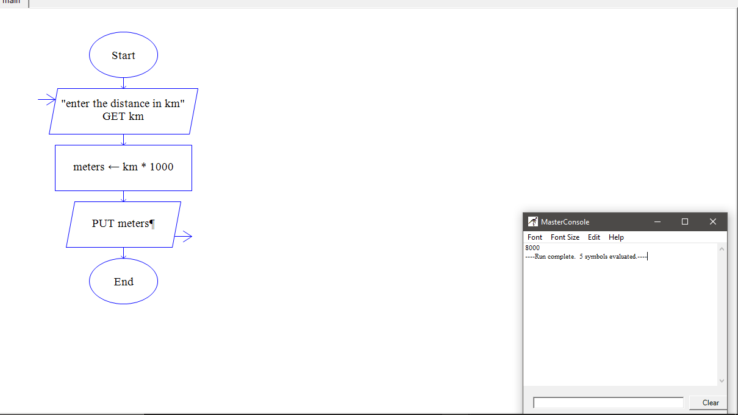

03.conversion of volume-

#include<stdio.h>

int main()

{

int ml,l;

printf("enter the volume in litres",l);

scanf("%d",&l);

ml=1000\*l;

printf("volume in ml is %d",ml);

return 0;

}

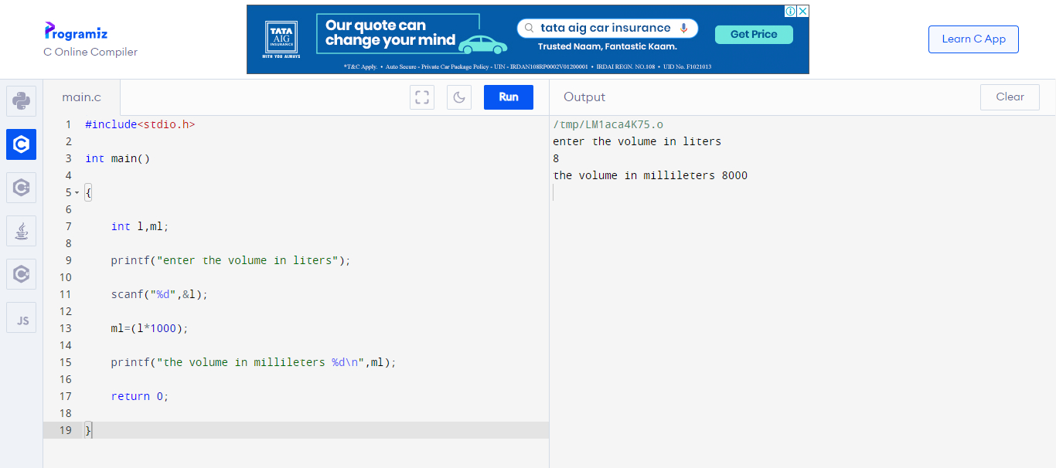

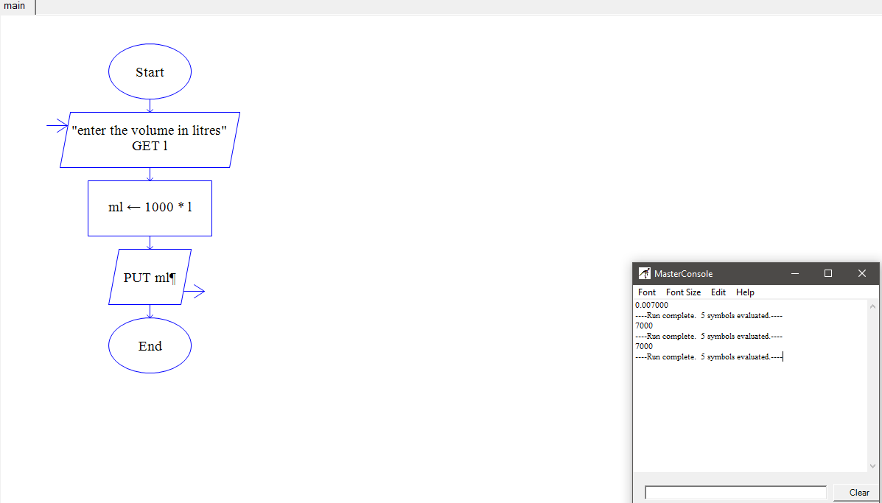

04.conversion of area-

#include<stdio.h>

int main()

{

float sqkm,acre;

printf("enter the disance in square kilometers");

scanf("%f",&sqkm);

acre=(sqkm\*247.105);

printf("the distance in acres is %.2f\n",acre);

return 0;

}

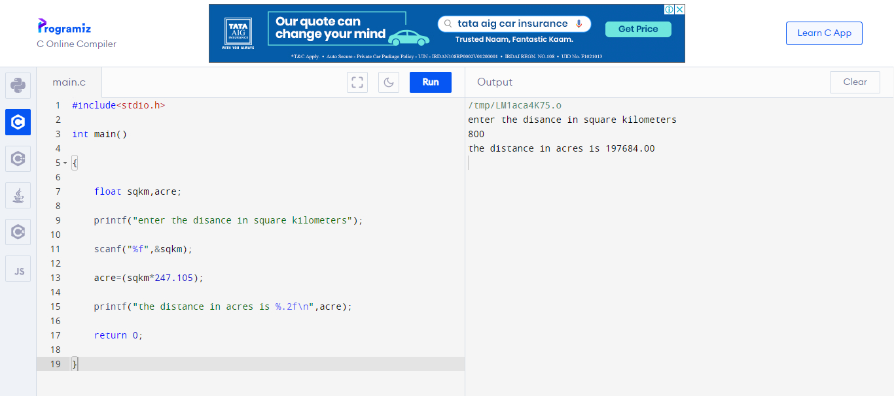

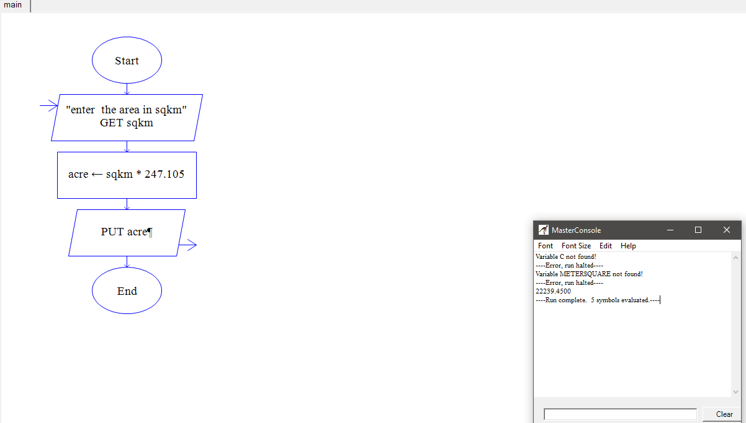

06.conversion of temperature-

#include<stdio.h>

int main()

{

int celsius,kelvin;

printf("enter the temperatuure in celsius",celsius);

scanf("%d",&celsius);

kelvin=celsius+273;

printf("in kelvin scale %d",kelvin);

return 0;

}

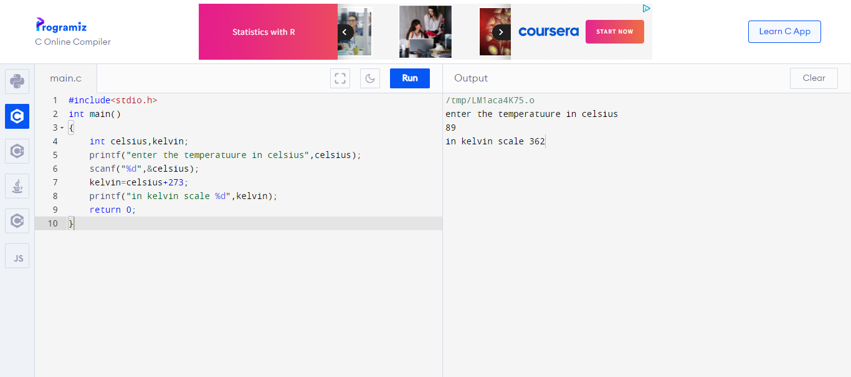

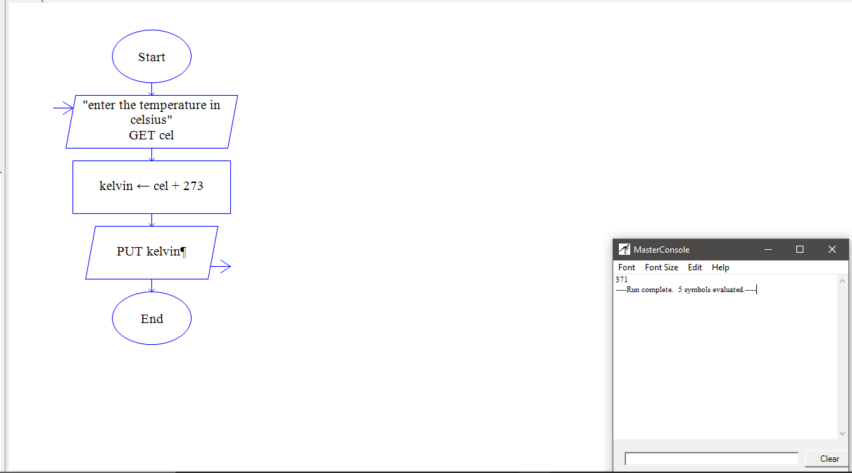

07.simple interest-

#include<stdio.h>

int main()

{

int p,t,r;

printf("enter the principle value");

scanf("%d",&p);

printf("enter the time");

scanf("%d",&t);

printf("enter the rate of intrest");

scanf("%d",&r);

float simpleintrest;

simpleintrest=(p\*t\*r)/100;

printf("the value of simpleintrest is %f",simpleintrest);

return 0;

}

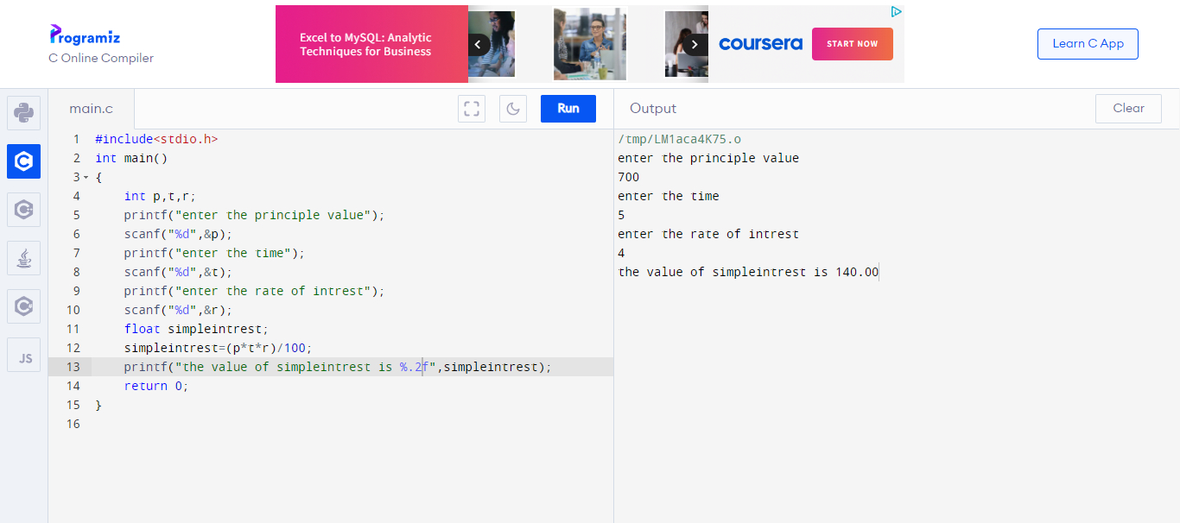

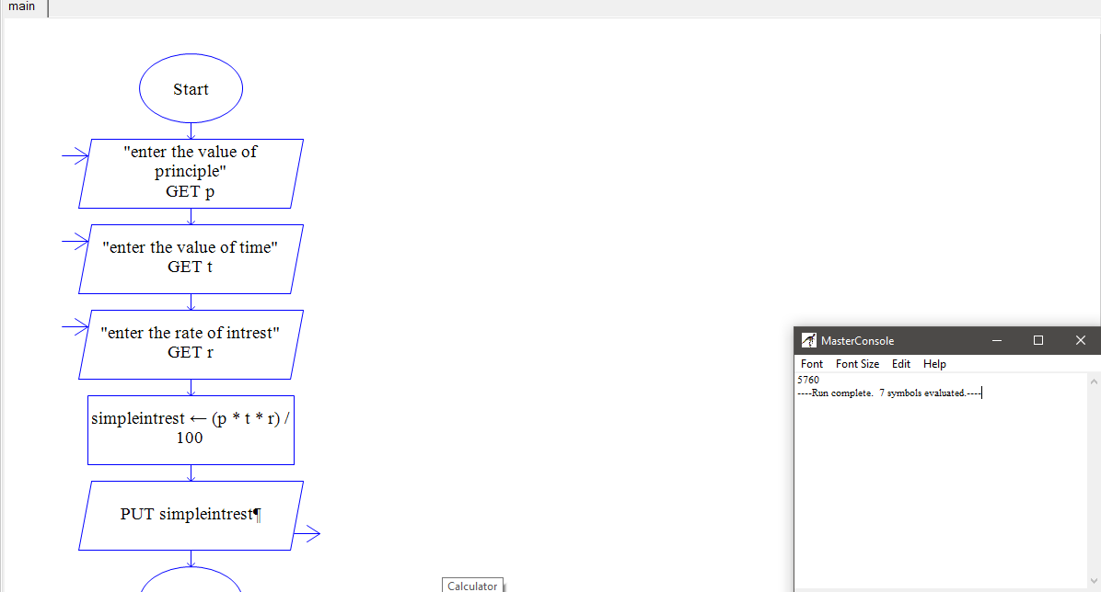

08.compound interest-

#include<stdio.h>

#include<math.h>

int main()

{

int p,t,r;

printf("enter the principle value",p);

scanf("%d",&p);

printf("enter the rate of intrest",r);

scanf("%d",&r);

printf("enter the time",t);

scanf("%d",&t);

float ci;

ci=p\*(pow((1+r/100),t));

printf("the compound intrest is %f",ci);

return 0;

}

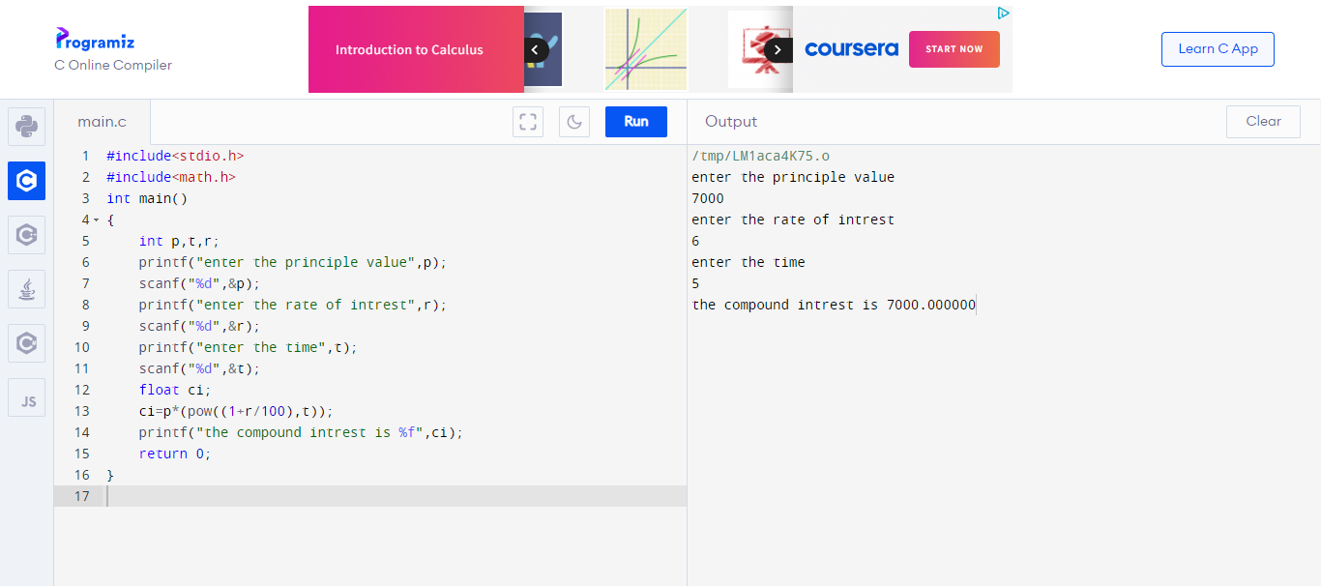

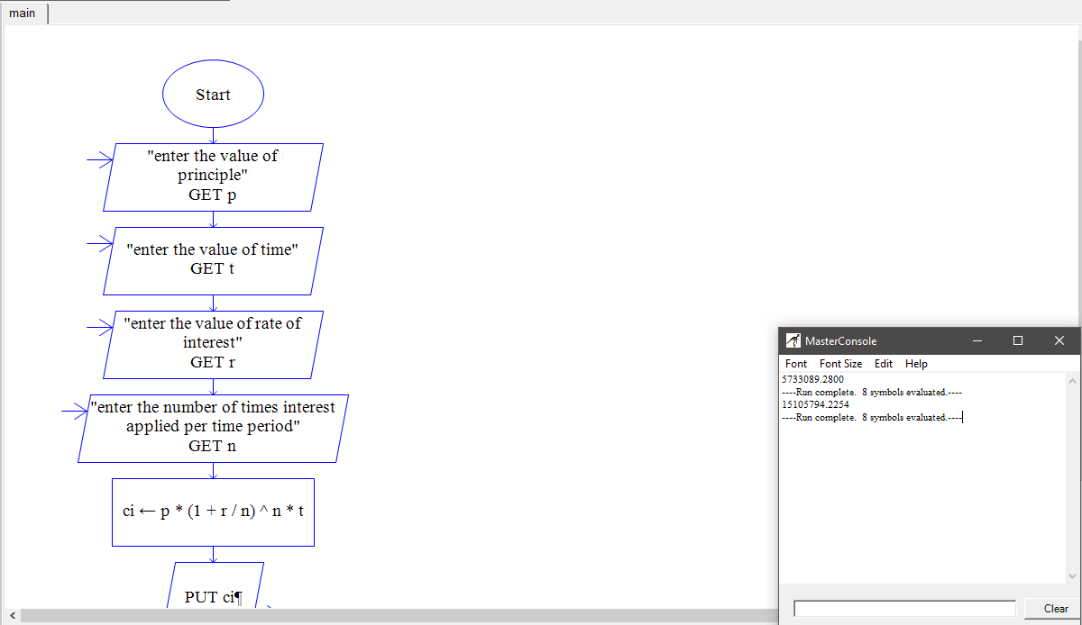

09.subject marks-

#include <stdio.h>

int main() {

int a,b,c,d,e;

printf("enter the marks obtained in a",a);

scanf("%d",&a);

printf("enter the marks obtained in b",b);

scanf("%d",&b);

printf("enter the marks obtained in c",c);

scanf("%d",&c);

printf("enter the marks obtained in d",d);

scanf("%d",&d);

printf("enter the marks obtained in e",e);

scanf("%d",&e);

int sum;

sum =(a+b+c+d+e);

int avg;

avg=sum/5;

float per;

per=avg;

printf("the sum is %d\n",sum);

printf("the avg is %d\n",avg);

printf("the per is %.2f",per);

return 0;

}

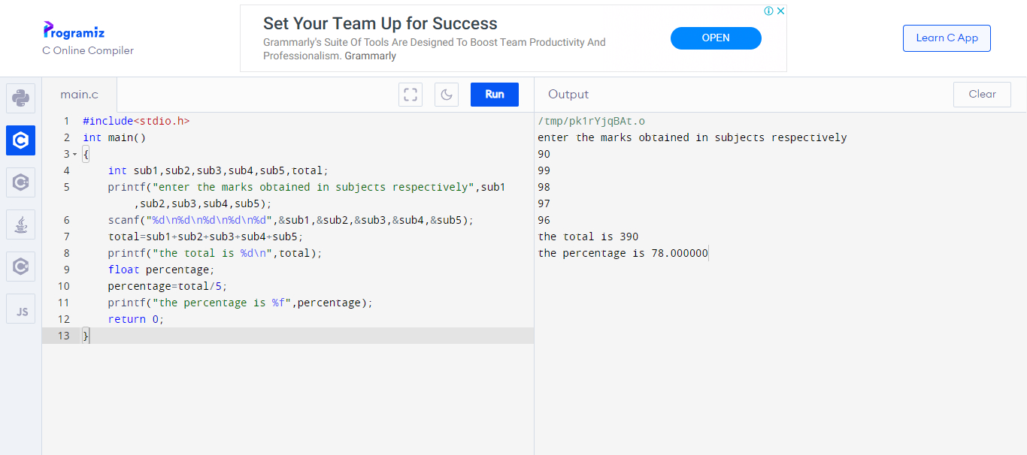

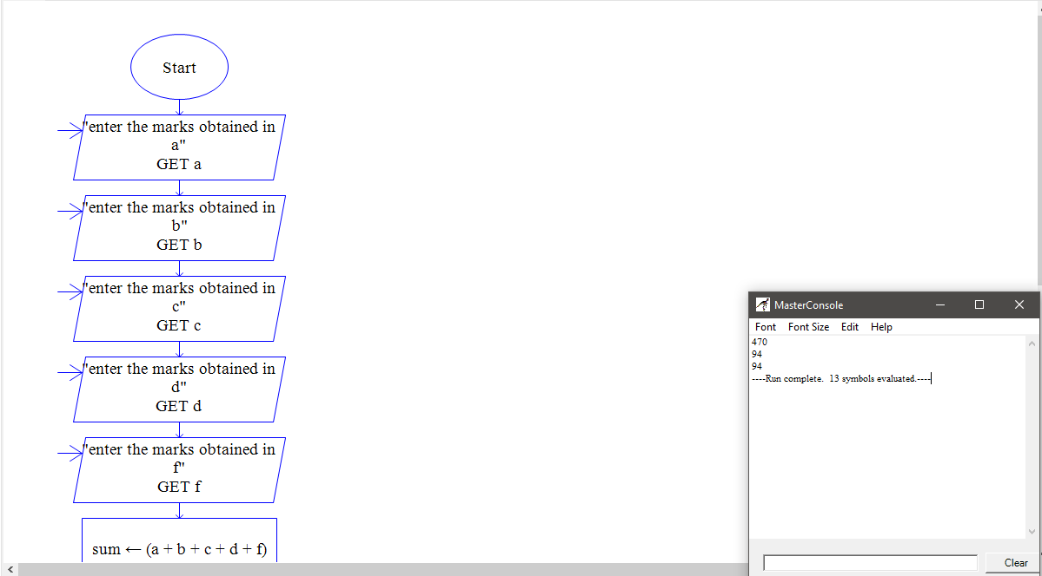

10.salary-

#include<stdio.h>

int main()

{

int basic,da,hra,pf,lic;

printf("enter the basic",basic);

scanf("%d",&basic);

printf("enter the da",da);

scanf("%d",&da);

printf("enter the hra",hra);

scanf("%d",&hra);

printf("enter the pf",pf);

scanf("%d",&pf);

printf("enter the lic",lic);

scanf("%d",&lic);

float netsalary;

netsalary=basic+da+hra-lic-pf;

printf("the net salary is %.2f",netsalary);

return 0;

}

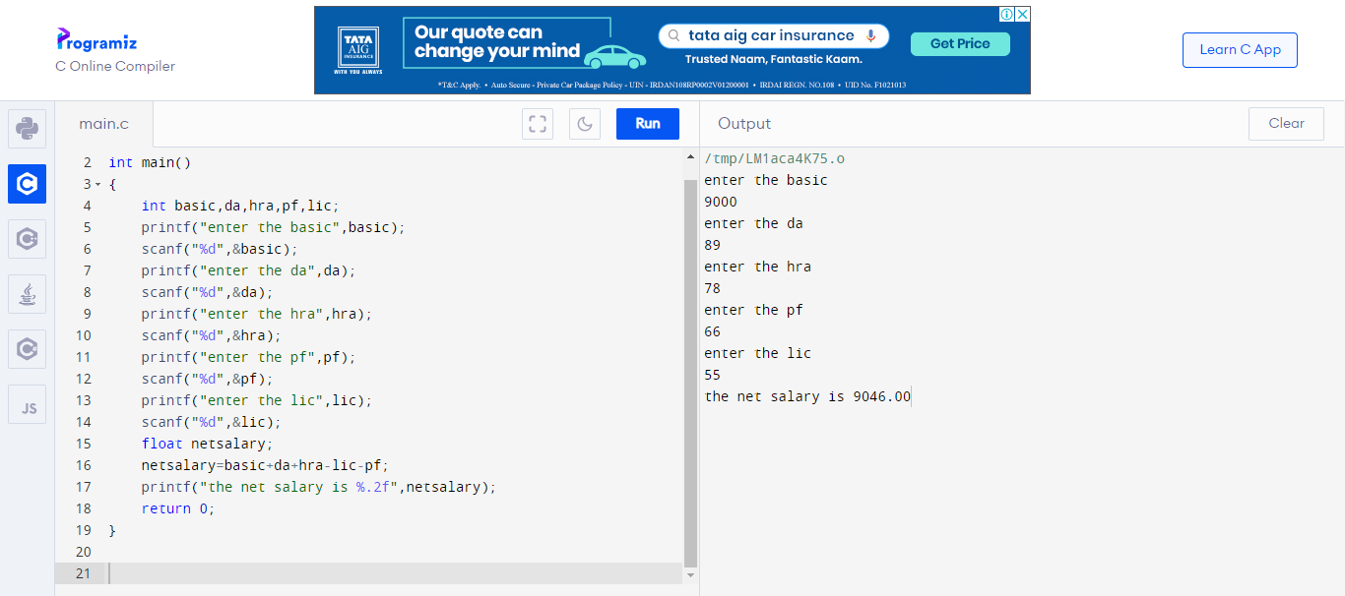

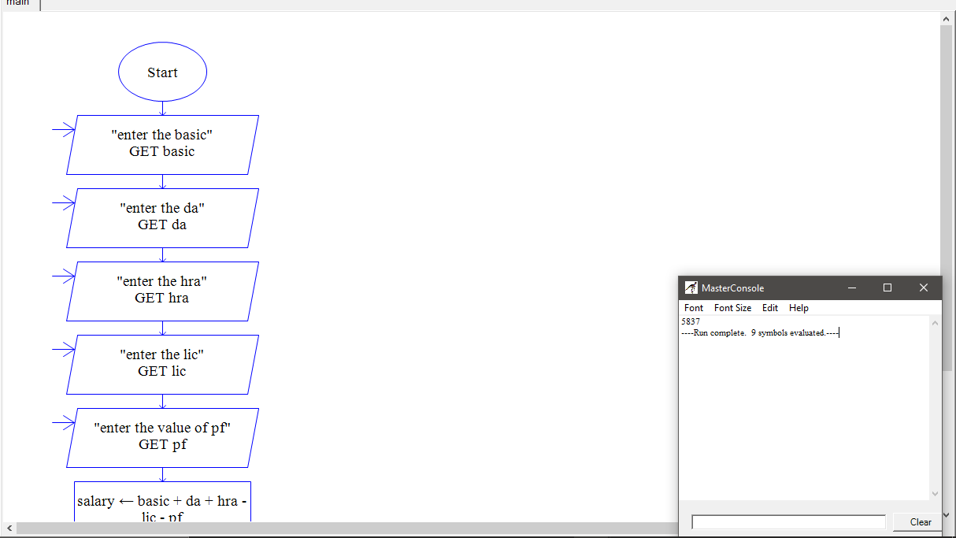

11.retreiving the remainder-

#include<stdio.h>

int main()

{

int dividend,divisor,remainder;

printf("enter the dividend",dividend);

scanf("%d",&dividend);

printf("enter the divisor",divisor);

scanf("%d",&divisor);

while(dividend>=divisor)

{

dividend=dividend-divisor;

}

remainder=dividend;

printf("the remainder is %d",remainder);

return 0;

}

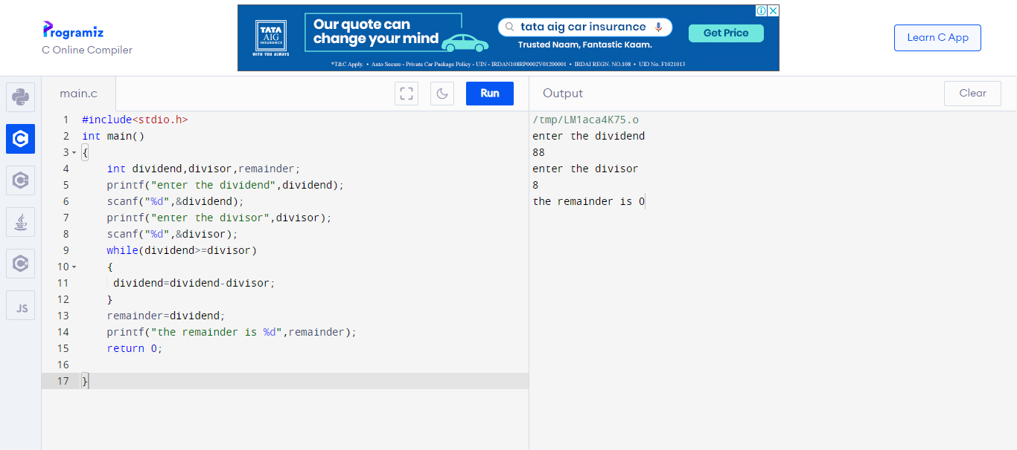

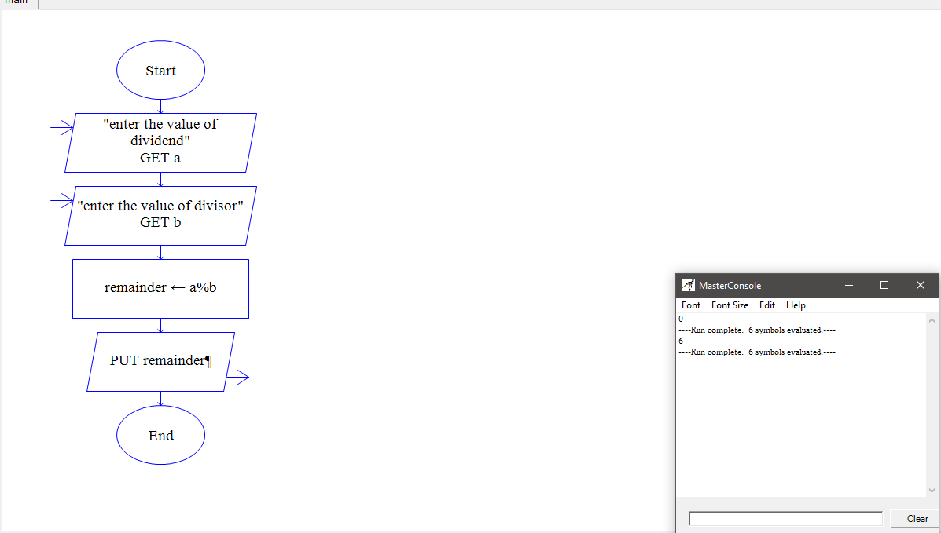

12.upper case to lower case-

#include<stdio.h>

#include<string.h>

int main()

{

char upr;

int ascii;

printf("enter the upper case character");

scanf("%c",&upr);

ascii=upr+32;

printf("%c character in lower case is %c",upr,ascii);

return 0;

}

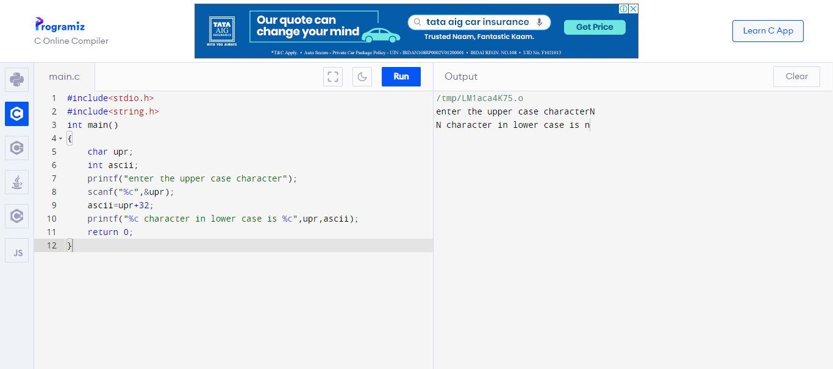

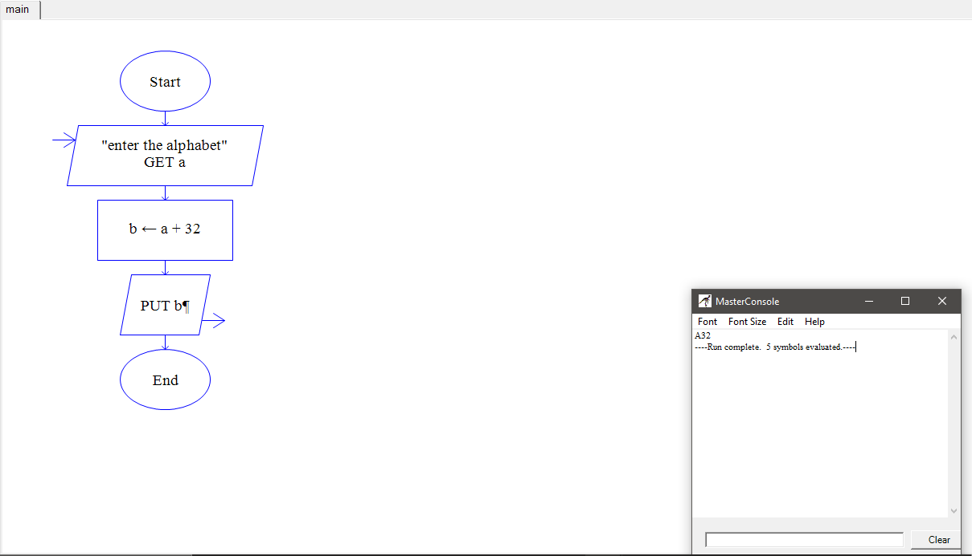

13.swapping of numbers-

#include <stdio.h>

int main()

{

int x, y;

printf("enter the value of x");

scanf("%d",&x);

printf("enter the value of y");

scanf("%d",&y);

int temp = x;

x = y;

y = temp;

printf("after swapping:x=%d,y=%d",x,y);

return 0;

}

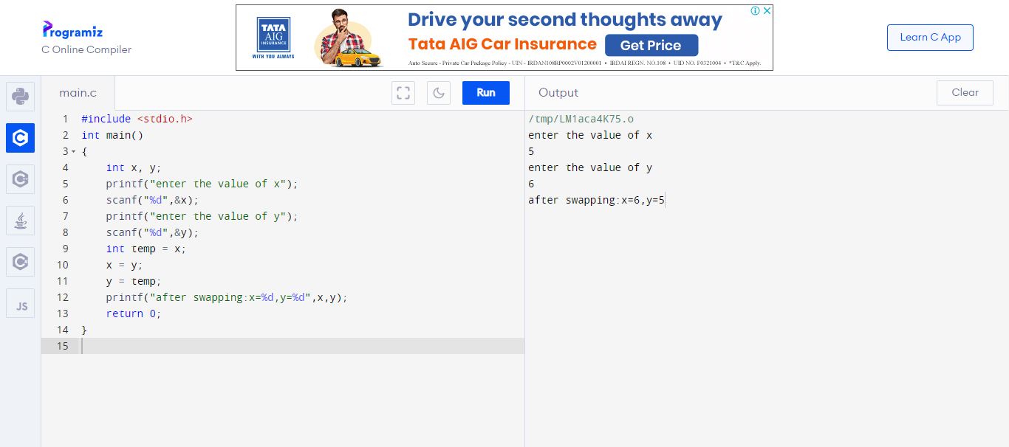

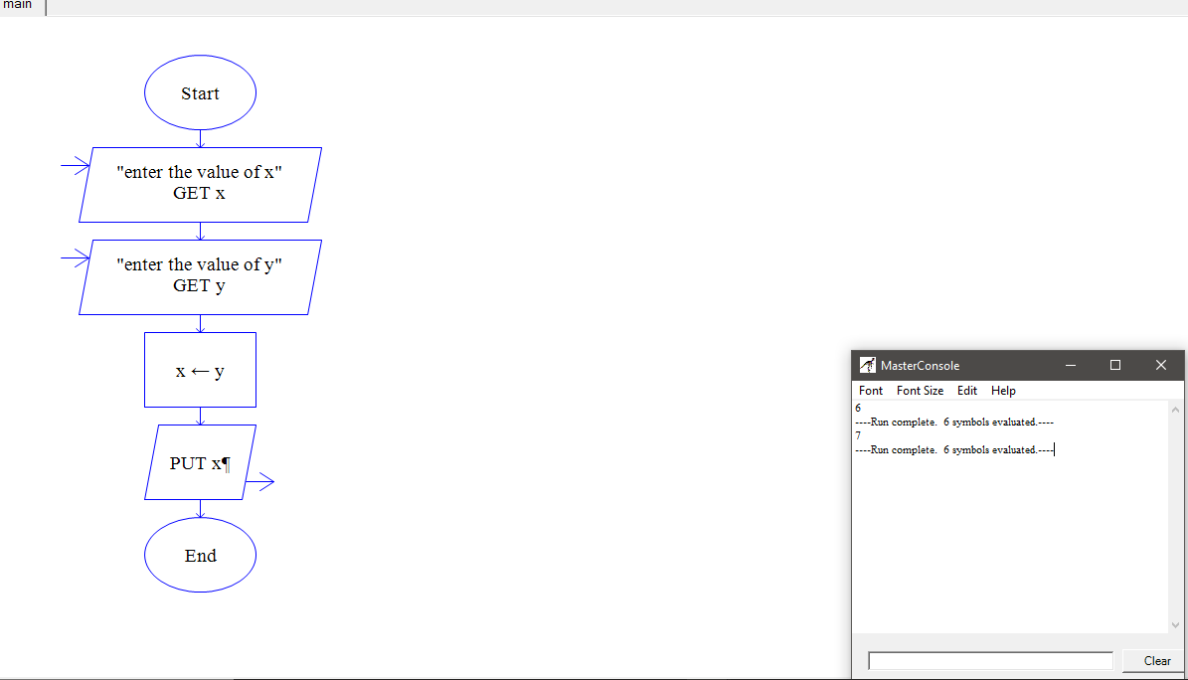

14.sum of the angles in a triangle-

#include <stdio.h>

int main()

{

int a,b,c,sum=180;

printf("enter the value of a",a);

scanf("%d",&a);

printf("enter the value of b",b);

scanf("%d",&b);

c=sum-(a+b);

printf("the value of c is %d",c);

return 0;

}

